# CS 340 Project Two README

## About the Project/Project Title

## The project, named Animal Shelter Database, is a Python application that serves as a middleware or glue layer between the MongoDB database and the user interface of a web application. It facilitates CRUD (Create, Read, Update, Delete) operations for managing animal records within the MongoDB database.

The Animal Shelter Database module is designed to provide a simple and efficient interface for interacting with MongoDB, specifically tailored for managing animal records in a shelter. Below is a brief explanation of how the module should be used:

**Initialization:**

- Instantiate the `AnimalShelter` class with the necessary parameters, including the MongoDB database name (`DB`), collection name (`COL`), user credentials (`USER` and `PASS`), host (`HOST`), and port (`PORT`).

Python example:

aac_db = AnimalShelter(DB, COL, USER, PASS, HOST, PORT

**CRUD Operations**:

- Create (`create`):** Insert new documents into the MongoDB collection.

Python example:

data_to_insert = {"name": "Tiger", "species": "Panthera tigris", "habitat": "Jungle"}

success = aac_db.create(data_to_insert

- Read (`read`):** Query and retrieve documents based on specified criteria.

Python example:

query_criteria = {"species": "Panthera tigris"}

query_result = aac_db.read(query_criteria)

- Update (`update`):** Modify existing documents based on specified criteria.

Python example:

update_criteria = {"species": "Panthera tigris"}

update_data = {"habitat": "Rainforest"}

updated_count = aac_db.update(update_criteria, update_data)

-Delete (`delete`):** Remove documents based on specified criteria.

Python example:

delete_criteria = {"species": "Panthera tigris"}

deleted_count = aac_db.delete(delete_criteria)

## Motivation

The motivation behind the Animal Shelter Database project is to streamline the interaction with a MongoDB database, specifically designed for managing information about animals in a shelter. By creating a middleware layer, it becomes easier for developers to integrate the database functionalities into a web application, promoting efficient data management and retrieval.

## Getting Started

To get a local copy up and running, follow these simple example steps.

## Installation

Ensure you have the following tools installed:

* Python 3+
* MongoDB
* Jupyter Notebook
* PyMongo Driver

Python Driver for MongoDB

The PyMongo driver was chosen for its robust features, active community support, and seamless integration with MongoDB. PyMongo is the official MongoDB driver for Python and provides a high-level API for interacting with MongoDB databases. Its ease of use and extensive documentation make it an ideal choice for developers working on Python projects that involve MongoDB integration.

To install the necessary Python packages, run:

**In your linux terminal:**

Pip install pymongo

**For reproducing the project**

Steps include installing MongoDB, installing/importing the (csv) data, user authentication setup, implementing CRUD operations as a Python module, and implementing an app that utilizes the CRUD module.

## Usage

The Animal Shelter Database can be utilized to perform CRUD operations on animal records in the MongoDB database. Below are examples of how to use the *library:*

### Code Example

**Python:**

# Instantiate the AnimalShelter class with authentication

aac_db = AnimalShelter(DB, COL, USER, PASS, HOST, PORT)

# Example data for insertion

data_to_insert = {"name": "Tiger", "species": "Panthera tigris", "habitat": "Jungle"}

# Call the create method

success = aac_db.create(data_to_insert)

if success:

print("Document inserted successfully!")

else:

print("Failed to insert document.")

# Example query

query_criteria = {"species": "Panthera tigris"}

# Call the read method

query_result = aac_db.read(query_criteria)

print("Query Result:")

for document in query_result:

print(document)

# Example data for update

update_criteria = {"species": "Panthera tigris"}

update_data = {"habitat": "Rainforest"}

# Call the update method

updated_count = aac_db.update(update_criteria, update_data)

print(f"Number of documents updated: {updated_count}")

# Example data for delete

delete_criteria = {"species": "Panthera tigris"}

# Call the delete method

deleted_count = aac_db.delete(delete_criteria)

print(f"Number of documents deleted: {deleted_count}")

### Tests

**Python:**

# Example query

query_criteria = {"species": "Panthera tigris"}

# Call the read method

query_result = aac_db.read(query_criteria)

print("Query Result:")

for document in query_result:

print(document)

**Dash Web Application**

Project Goals

The Dash web application within the Animal Shelter Database project aims to achieve the following goals:

1. User-Friendly Interface:

- Create an intuitive and user-friendly interface for users to interact with the Animal Shelter Database. This includes easy navigation, clear visuals, and straightforward controls for managing animal records.

2. Data Visualization:

- Implement effective data visualization tools to present insights and statistics related to animal records. This includes graphical representations of data trends, patterns, and distributions.

3. Filtering and Sorting:

- Enable users to dynamically filter and sort animal records based on various attributes such as species, habitat, and other relevant parameters. This enhances the ability to quickly find specific information.

4. Real-Time Data Updates:

- Implement real-time updates to ensure that users have access to the latest information from the MongoDB database. This is crucial for maintaining accuracy and timeliness in managing animal records.

5. Integration with CRUD Operations:

- Seamlessly integrate the Dash app with the CRUD (Create, Read, Update, Delete) operations provided by the AnimalShelter module. Users should be able to perform database operations through the web interface.

**Dash App Components**

The Dash app consists of the following key components:

- Data Tables: Displaying animal records in a tabular format with the ability to dynamically update based on user interactions.

- Graphs and Charts: Providing visual representations of data trends, including pie charts, bar graphs, or any other relevant visualization to enhance data understanding.

- Interactive Filters: Allowing users to filter data based on specific criteria, improving the efficiency of locating and managing records.

**Running the Dash App**

To run the Dash web application, ensure you have the following prerequisites:

- Python 3+

- Dash library

Install the required Python packages:

bash

pip install dash dash-bootstrap-components

### Screenshots

**Import and Execution**

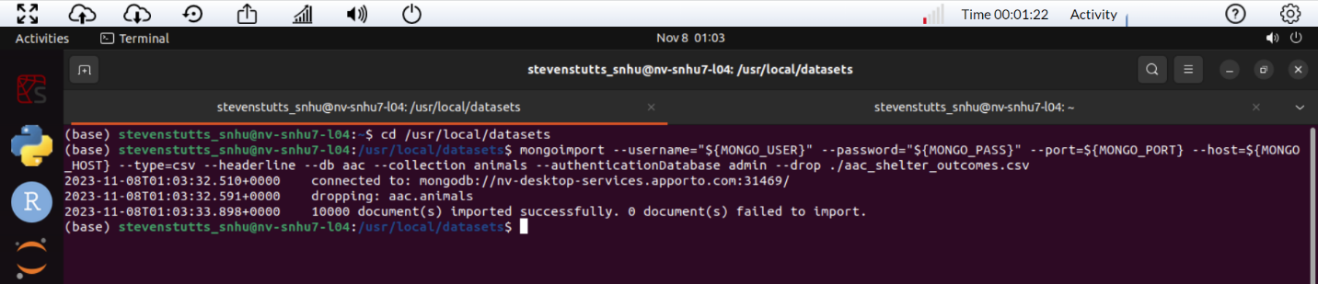

**Simple Index and Explain Function**

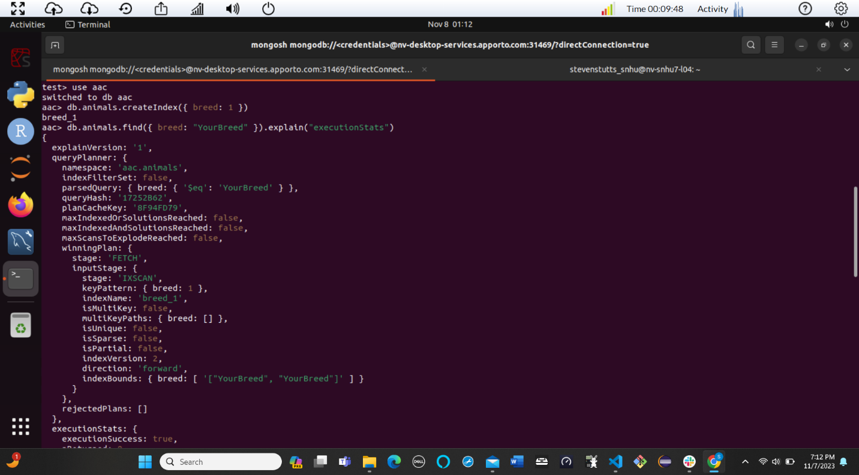

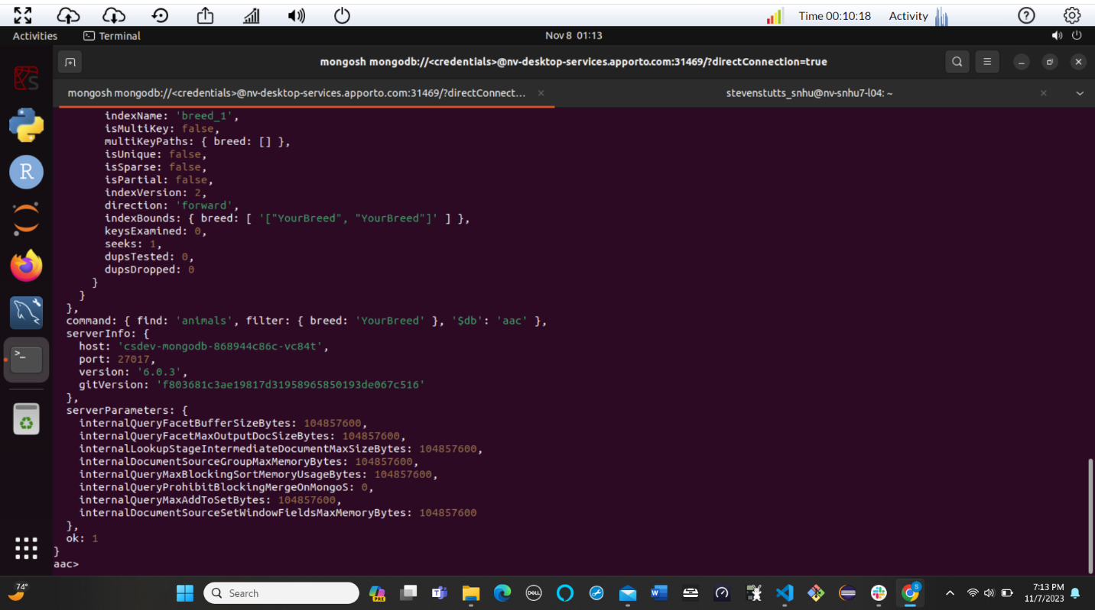

**Compound Index and Explain Function**

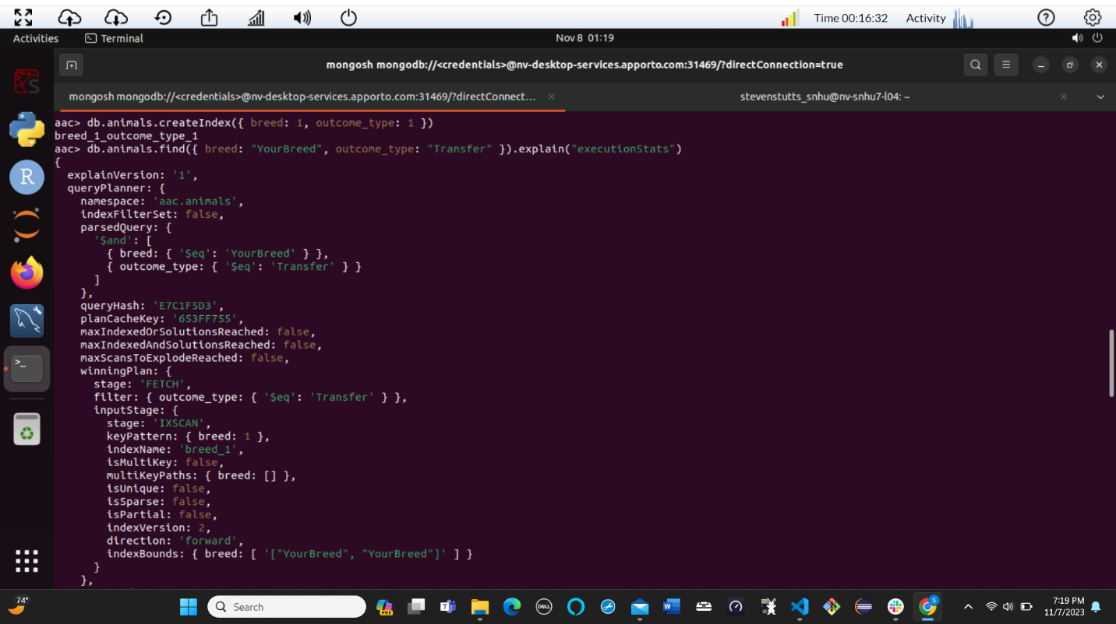

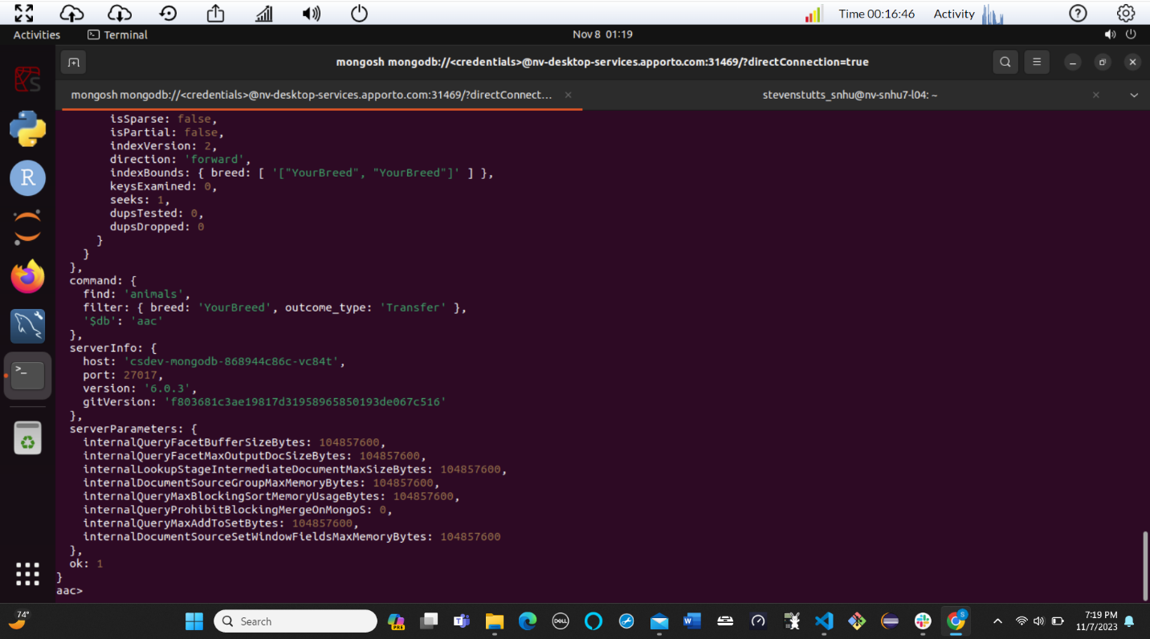

Part II: Creating a User

**Ensures User Authentication**

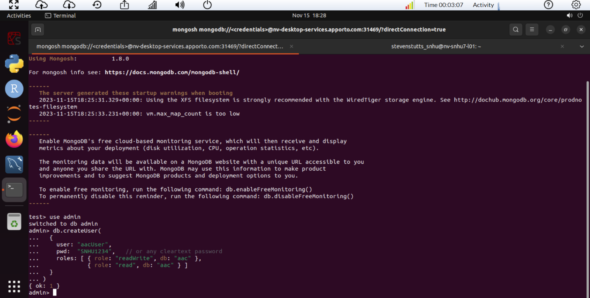

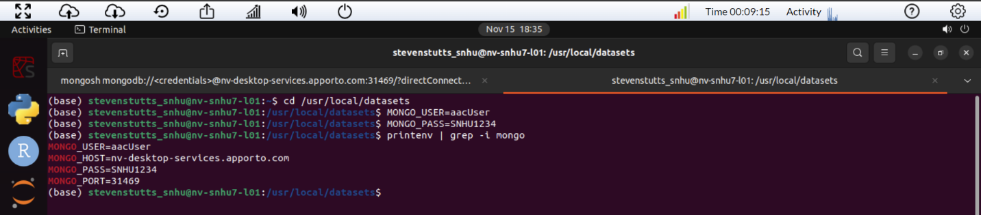

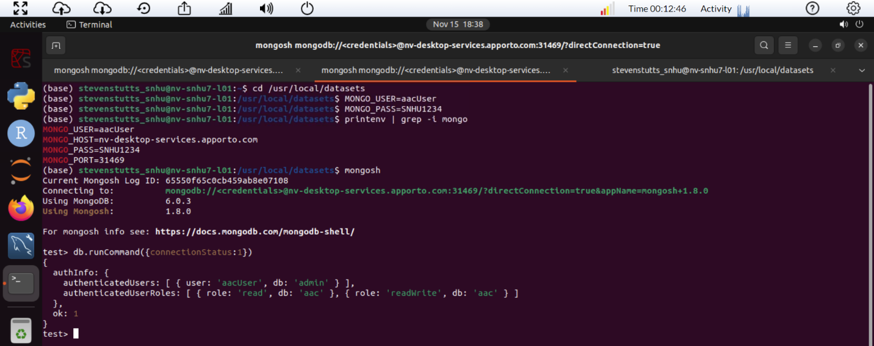

**CRUD Python Module Screenshots**

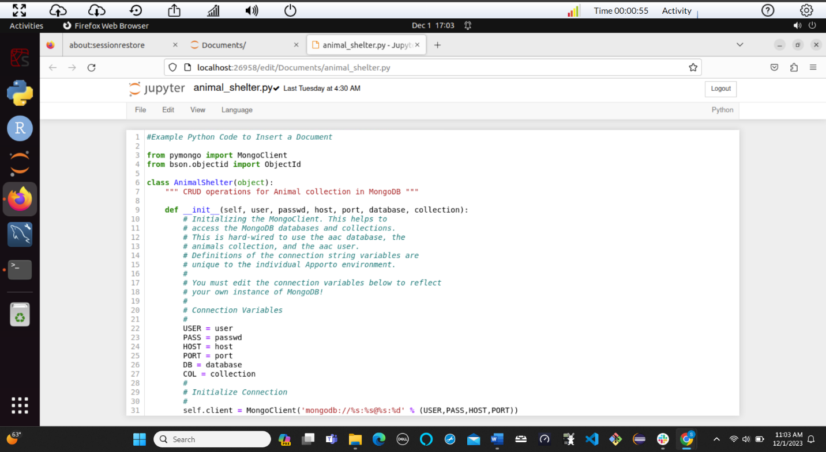

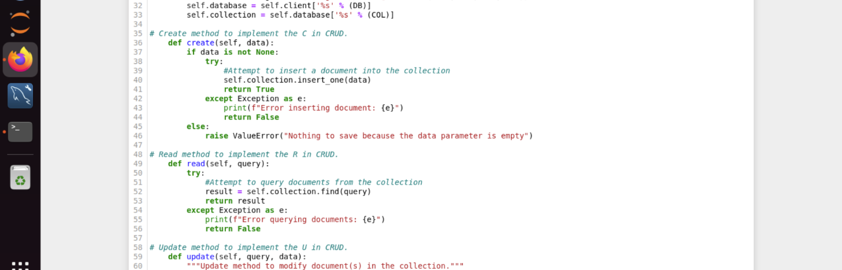

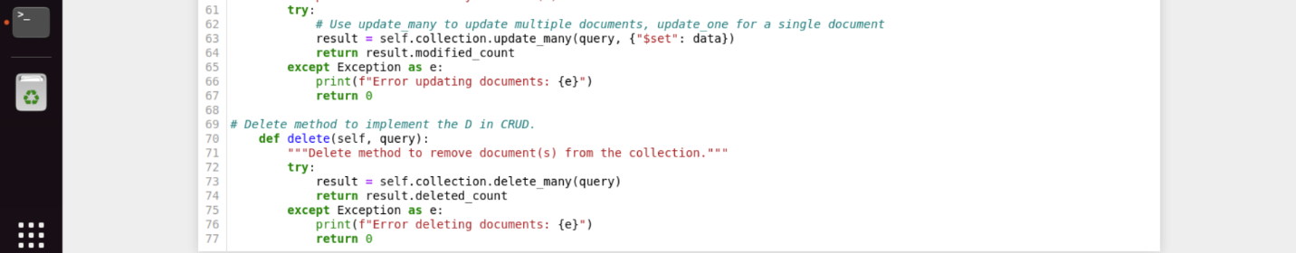

**Commands and execution of Python test script screenshots**

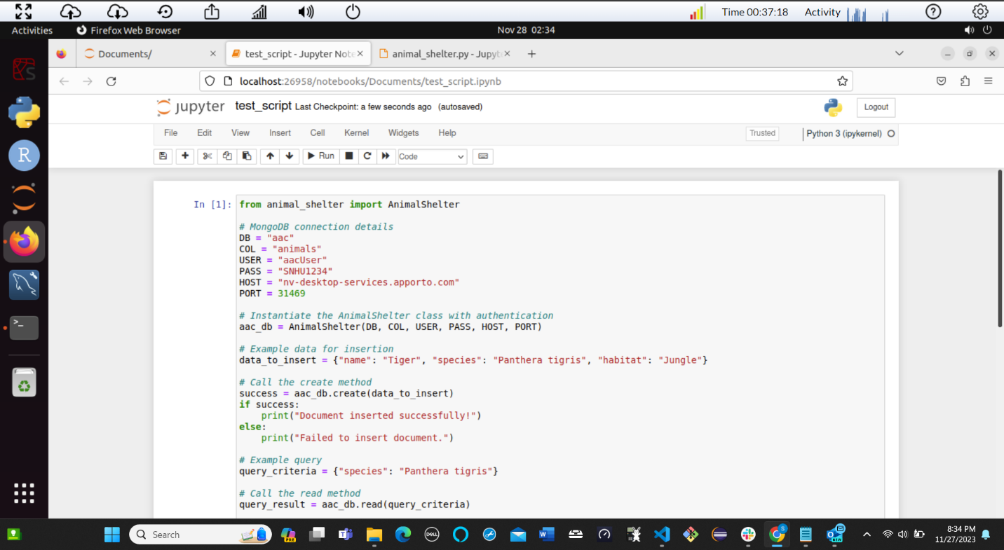

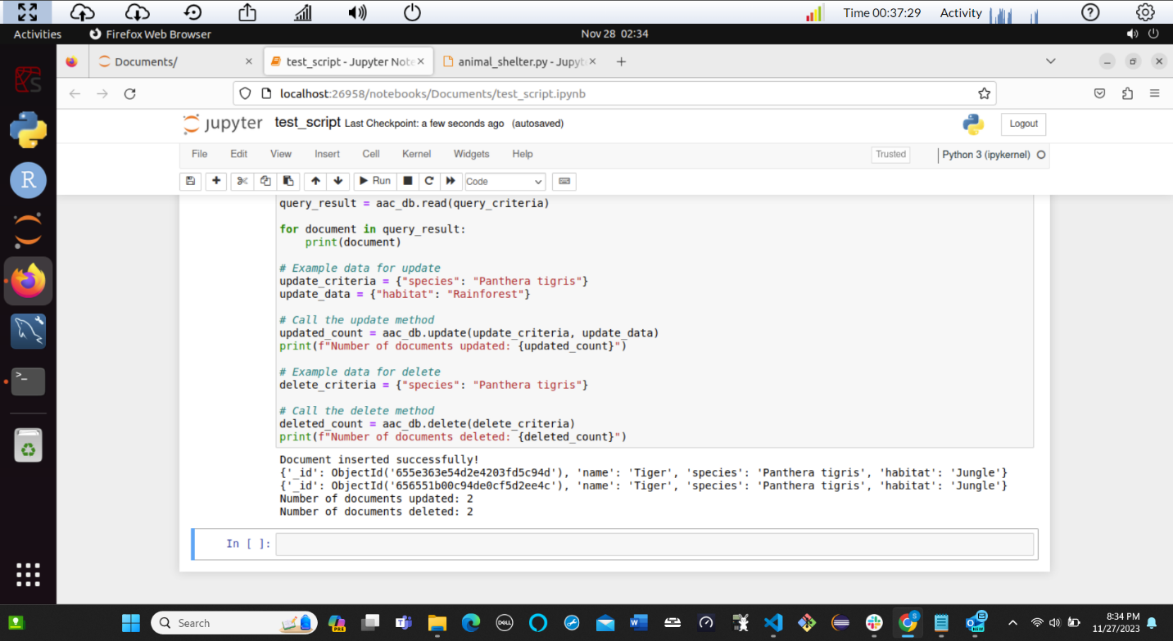

**The complete Dash App Code Execution**

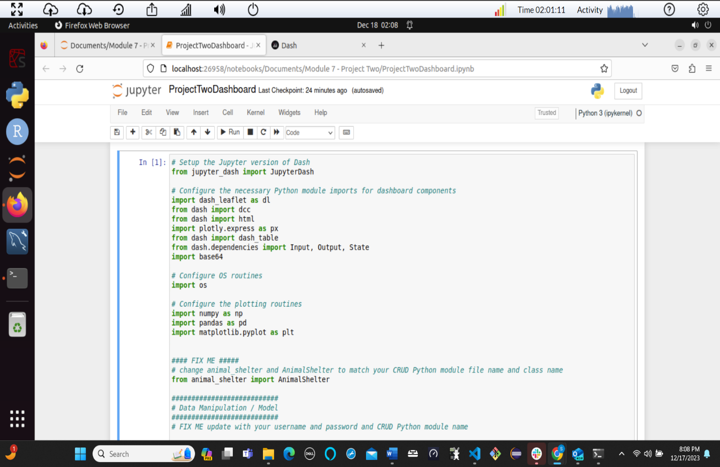

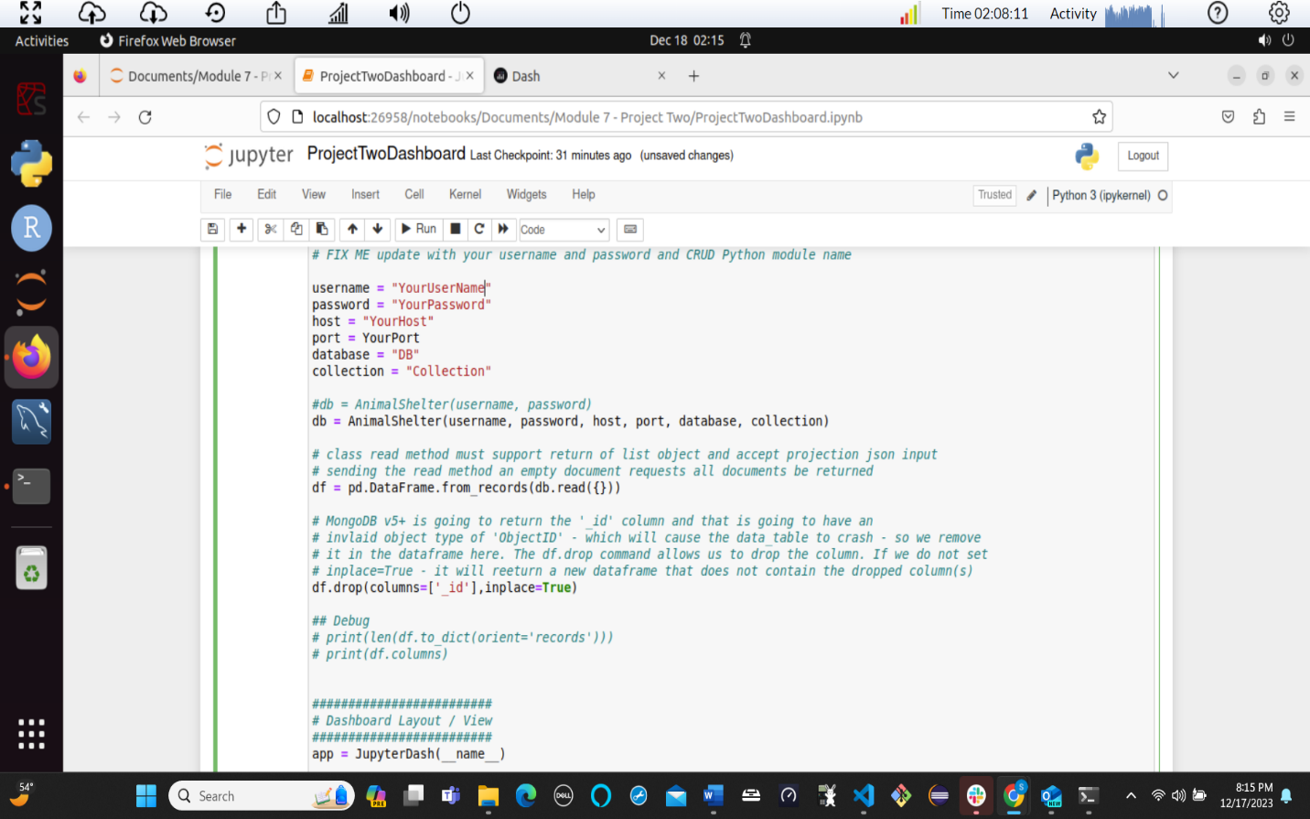

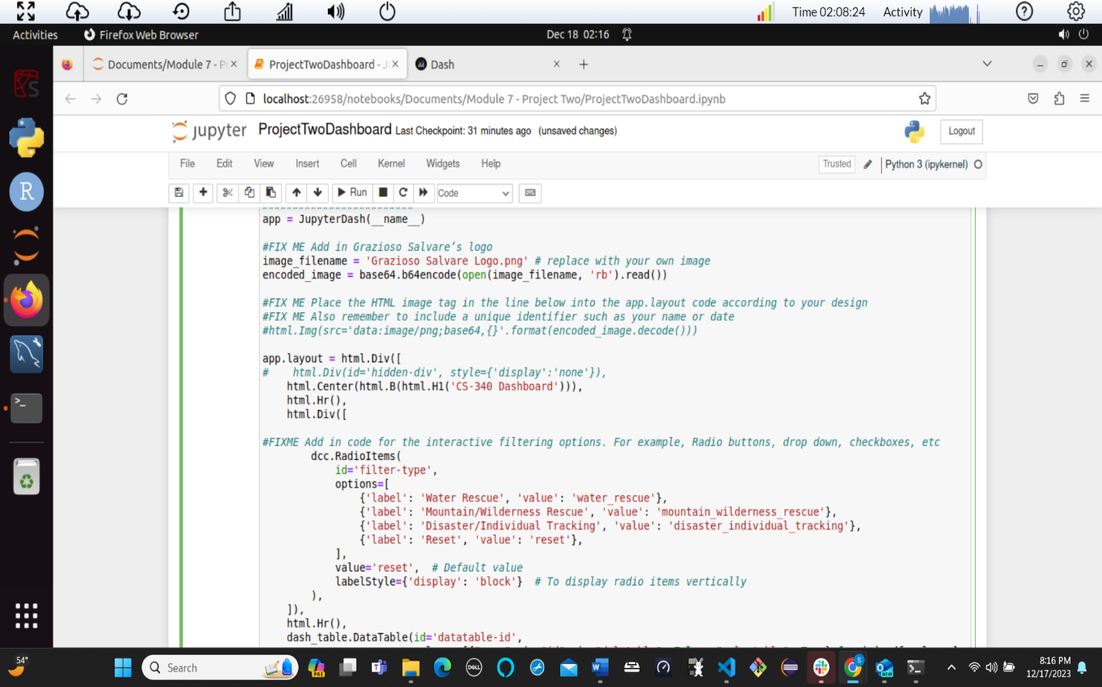

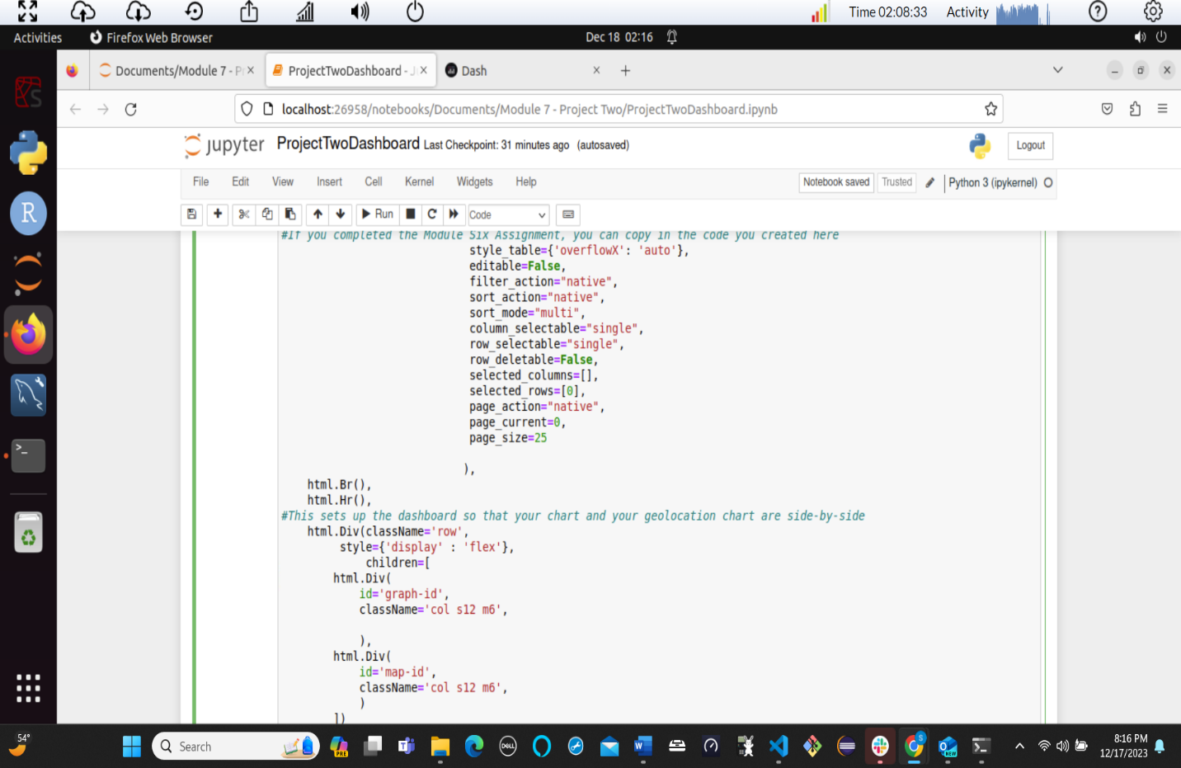

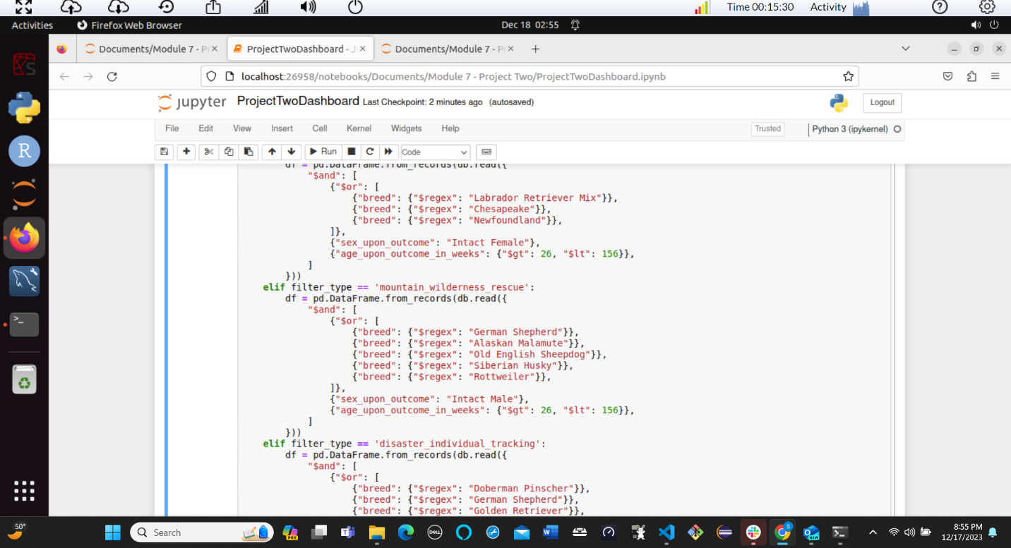

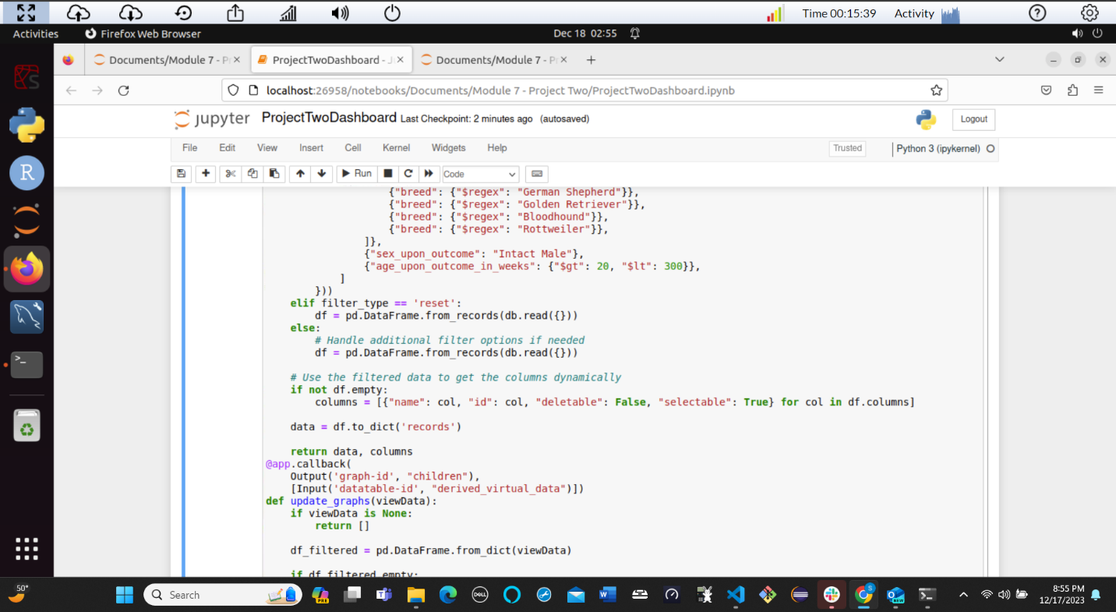

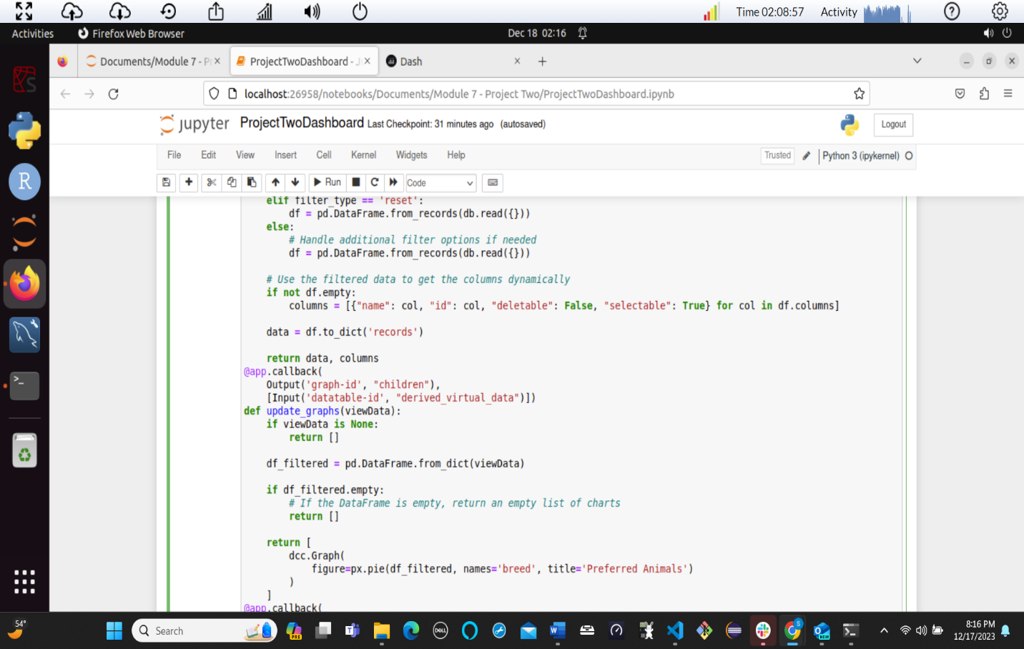

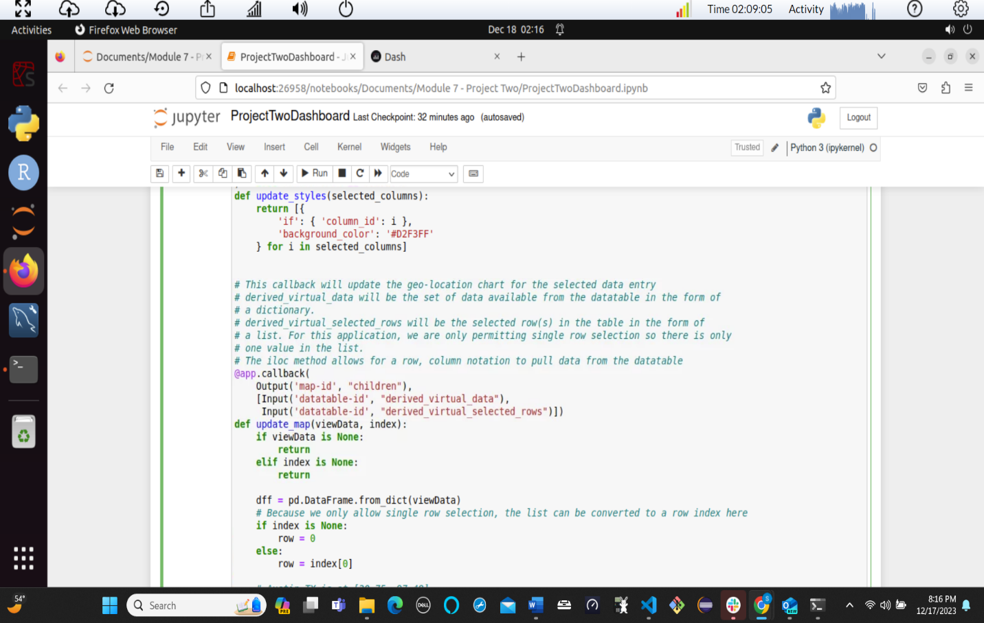

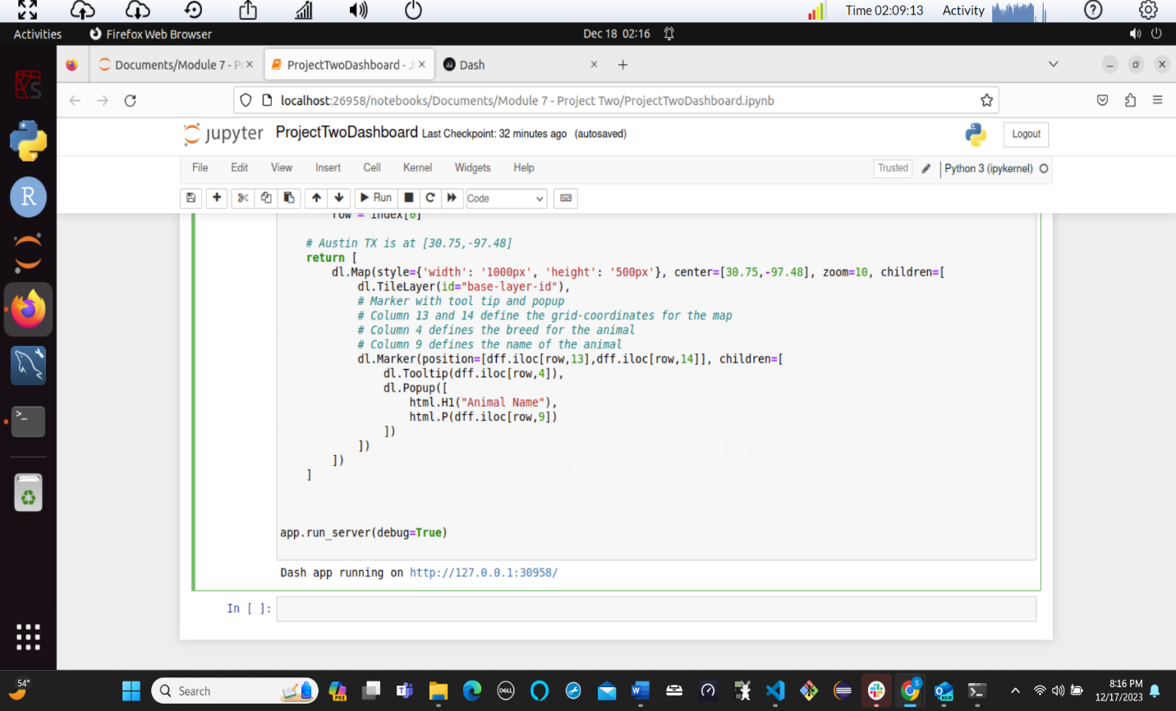

**Interactive Table, Chart, and Geolocation map**

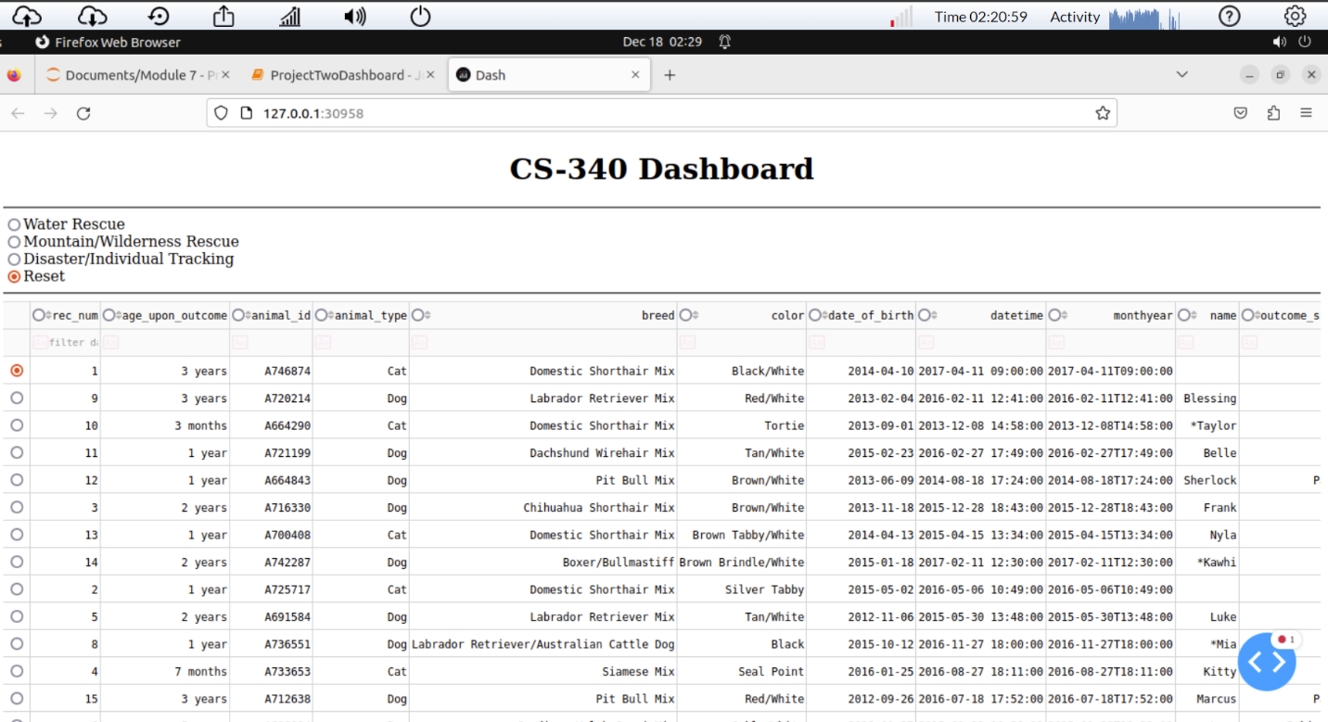

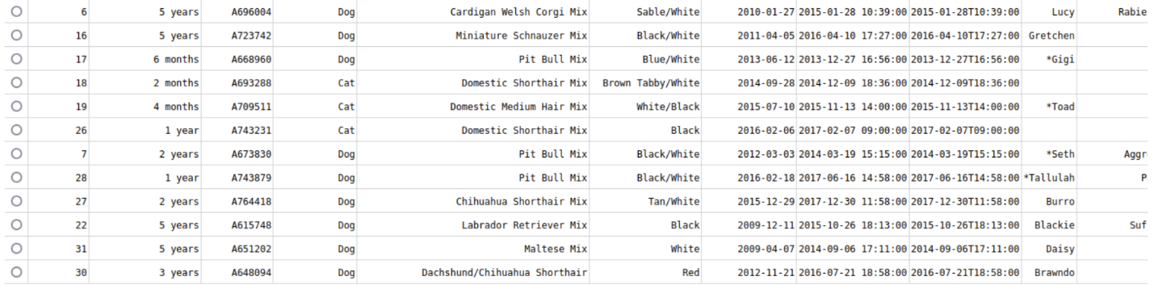

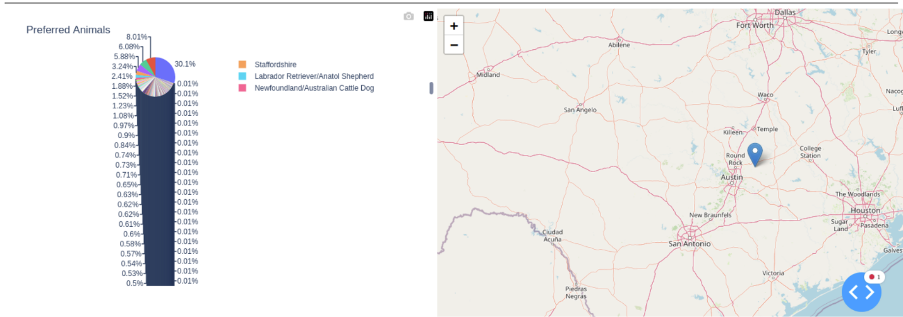

## Contact

Steven Stutts